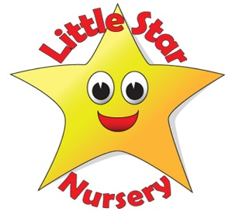
Getting to know…..Abbie
Tell us a little bit about the road you have travelled so far that has led you to working at Little Star Nursery….
After completing my GCSE’s I went straight to college to study my level 3 in children’s learning and development. I completed the 2 years course in the June and began my journey at Little star’s in the October. I started working afternoons and have built it up and now key person to babies and toddlers.
What is your principle motivation for working with children?
To laugh, smile and have fun!
What can we usually find you doing on a Saturday afternoon?
Shopping (what I do best!)
How do you relax?
Chilling in my pjs.
Who is your hero?
My grandad
What would your desert Island luxury be and who (other than your family) would you want to be marooned with?
Cannot live without hand soap, and who would I like to be marooned with? Its got to be David Beckham.
Are you a camper or a glamper?
Glamper
What’s your earliest childhood memory?
Playing in the garden at my grandparents.
Sandcastles or snowmen?
Sandcastles
And your final words of wisdom……?
“Don’t let anyone dull your sparkle…”

