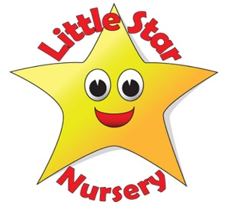
Getting to know…..Vicki
Tell us a little bit about the road you have travelled so far that has led you to working at Little Star Nursery….
I have 4 children and used to work at a Pre-school in Keynsham for 10+ years and helped out at Castle Primary school. We then moved to Clutton in 2006 where I helped out in Clutton school and in 2008 I applied for a job with Little star Nursery and started on the 8th of September.
What is your principle motivation for working with children?
To see the smile on their faces when they achieve their goals and knowing that everyday is different and full of wonderful and sometimes unexpected surprises.
What can we usually find you doing on a Saturday afternoon?
Chores, walking the dog and playing games.
How do you relax?
Chilling out in the hot tub.
Who is your hero?
My hero has to be Nelson Mandela who showed the courage to fight against an unjust system of apartheid.
What would your desert Island luxury be and who (other than your family) would you want to be marooned with?
Aston Martin DB5 and Tom Hanks
Are you a camper or a glamper?
Has to be a glamper.
What’s your earliest childhood memory?
Sitting in a speed boat made from sand which my dad made.
Sandcastles or snowmen?
Sandcastles.
And your final words of wisdom……?
Find what you love to do and pursue it.

