
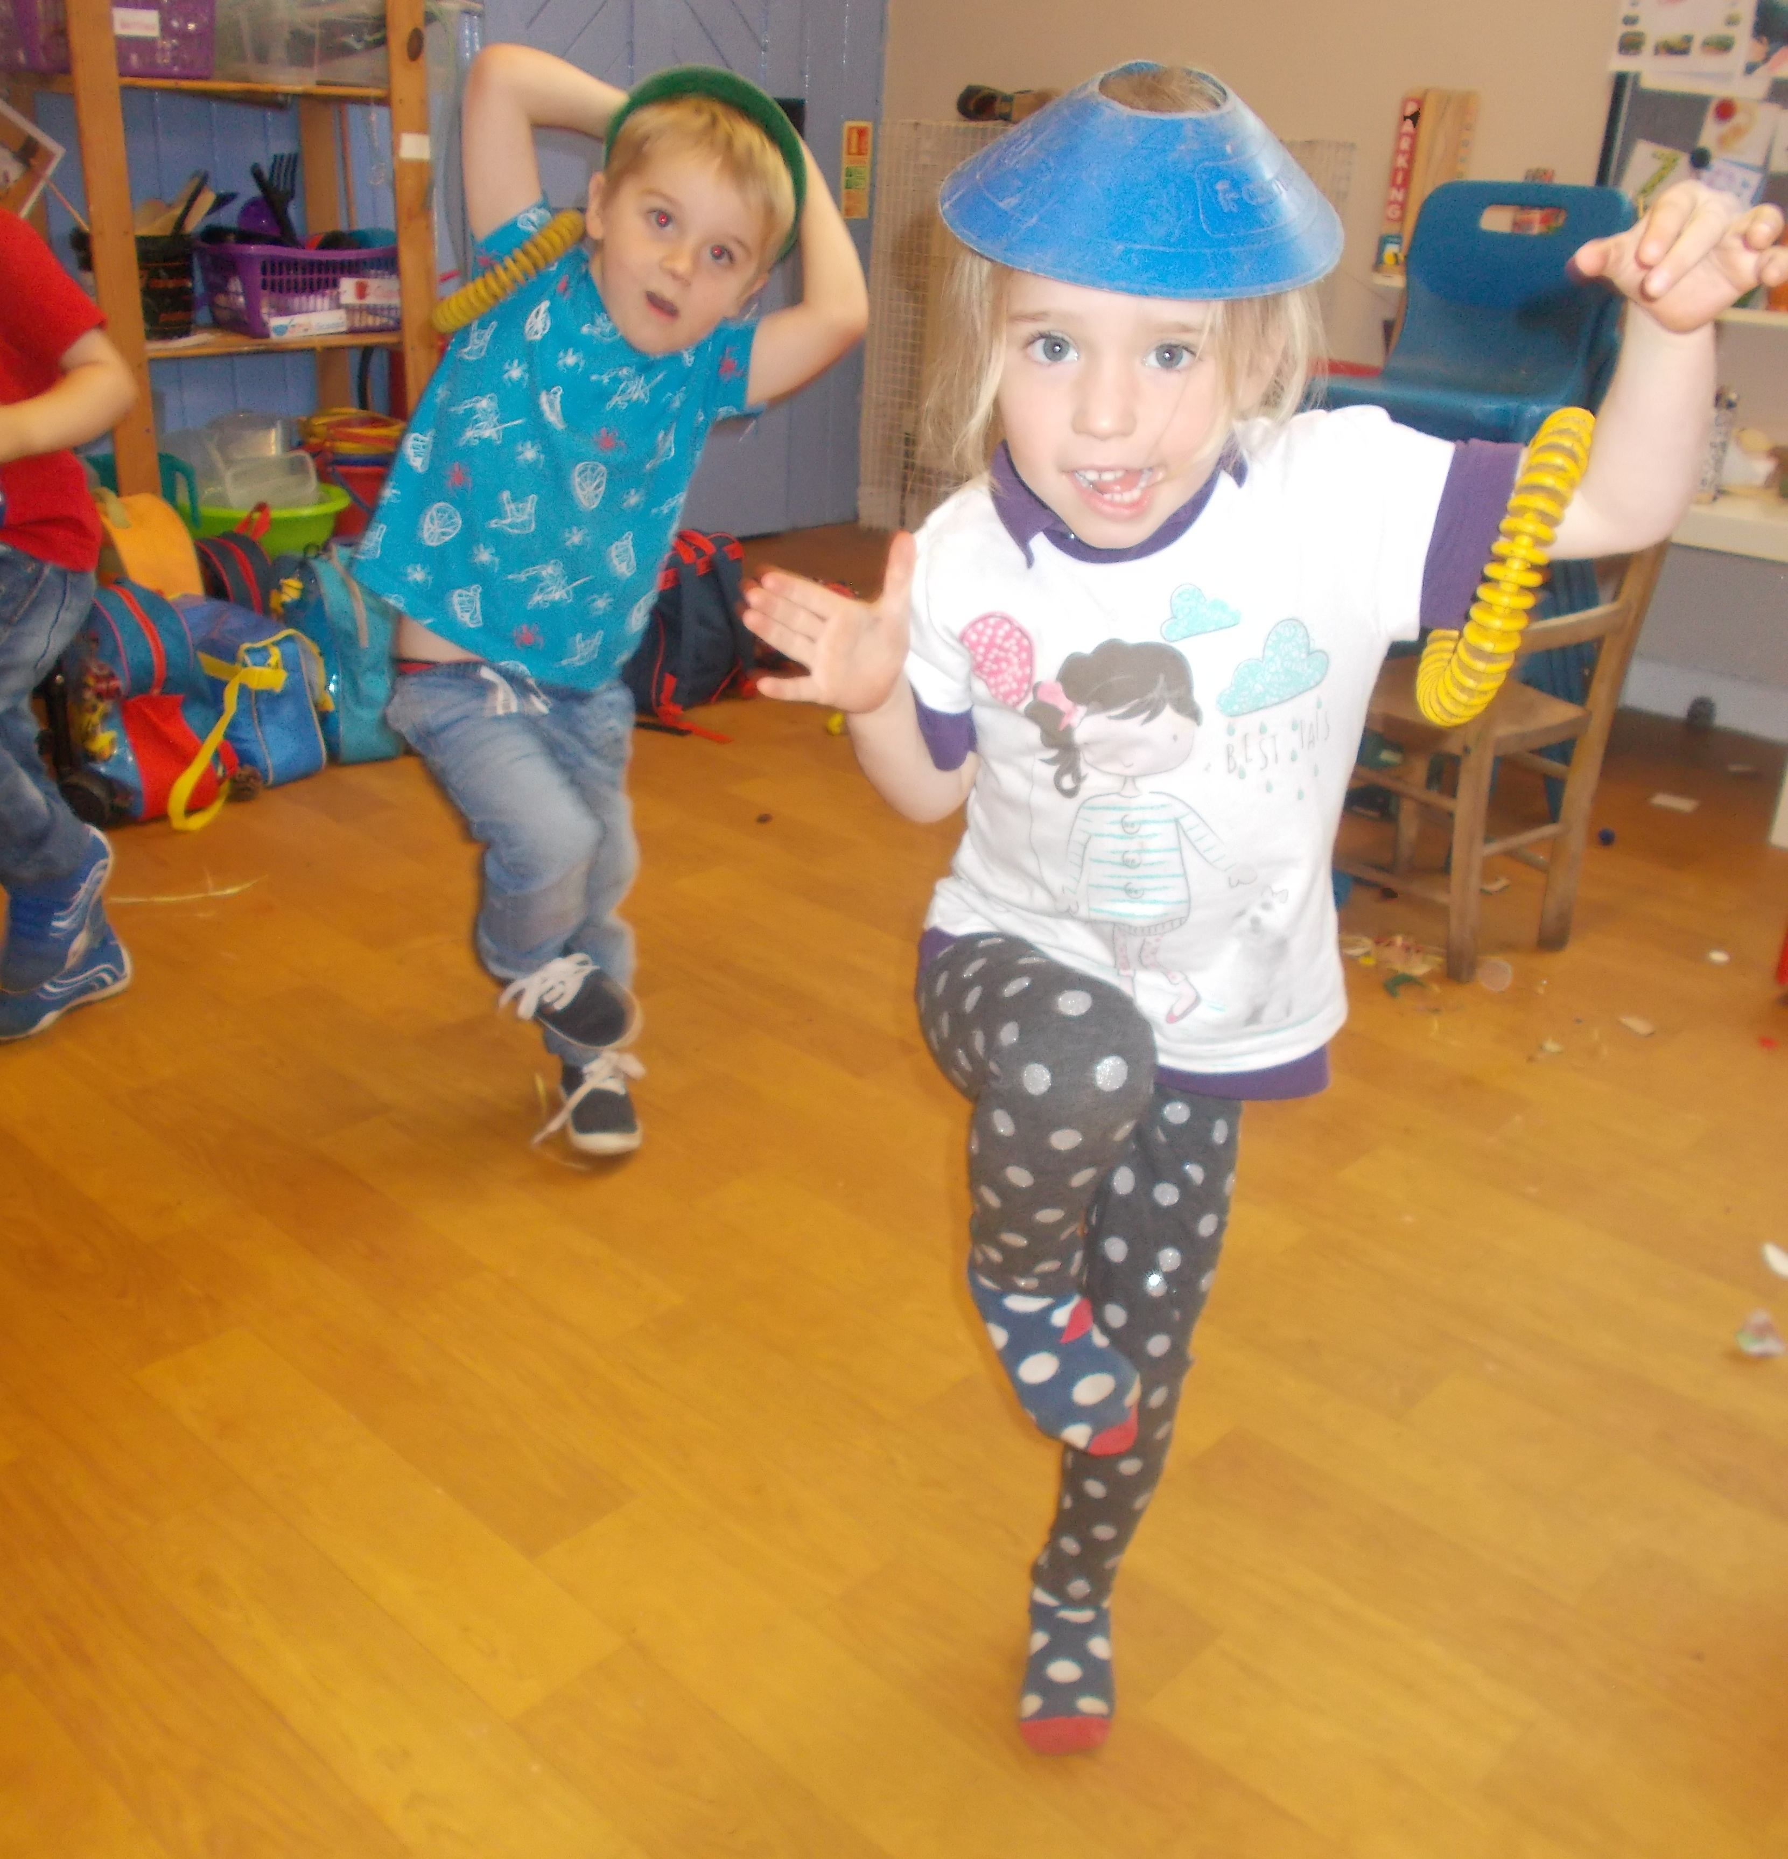
Next
steps
To spread the ‘First Fun’ strategy to all children in the nursery and to have all staff aware of how to use the resources, so that is used across all children in the setting.
Outcome
Physical Activity

Increase the amount of varied and planned physically active play experiences led by practitioners for all children every week.
What children and families think?

Children are energised at the start of the day through the ‘get up and go’ sessions and it gives them all focus as well as being able to “let off steam” before they engage in another activity. They remember moves such as some of the yoga positions: “Look: I’m a dog!” and choose music to move to: “Can I have the ‘sunshine in my pocket’ song?”
They remember the focus of the first fun stories, and show parents how they can balance on one leg like a pirate. Families tell us that they have demonstrated these ways of moving, balancing etc at home and come to nursery proud that they have practiced “balancing for 10 counts!”

Why we chose this outcome
We felt as a setting that we already had a firmly embedded ethos and provision for outdoor experiences which included a lot of physical activity (either in the garden, park or in local countryside, woods) and lots of access for the children to the outdoors. However we felt that these experiences for physical activity may not be echoed with indoor provision.
What we did
A member of staff attended the training where they delivered the ‘First Funs’ scheme. This was then introduced to the nursery with a group of older children to resounded good reception and so it was shared with other members of staff.
The sessions were held both indoors as well as out in the garden/ fields.
We also introduced “get up and go” sessions at the start of every day where the separate groups of older children and younger would all have the chance to be active for 10 minutes. These sessions are varied, from following a dance routine to a pop song, to a yoga inspired session.

Impact

Children like the routine of the ‘get up and go’ sessions and say they are “ready for the day”. It helps to focus on what comes next and burn off energy. It is particularly helpful for children who display difficulties in concentrating or sitting still: they are then more likely to be able to focus on a subsequent activity that is more stationary.

Seeing the positive effect that it has in the morning, staff introduce similar movement sessions throughout the day: for example following times where children may have been sitting still for a long time or when they may need to “re group” and focus.

The positive effect of the first fun sessions will result in it being carried through the nursery more extensively.

Healthy Outcomes Certificate
For Early Years - Case Study

