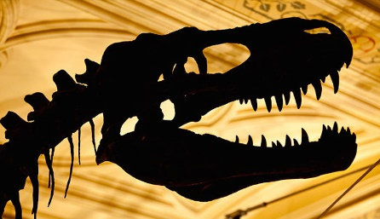
We're going on a dinosaur hunt
We're going on a dinosaur hunt. We’re going to find an enormous one. What an exciting day. We're not afraid.
Uh oh a forest, a thick, tropical forest. We can't fly over it, we can't wriggle under it, we've got to forge through it: Slash! Bash! Slash! Bash!
We're going on a dinosaur hunt. We’re going to find an enormous one. What an exciting day. We're not afraid.
Uh oh a swamp, a vast, gooey swamp. We can't fly over it, we can't wriggle under it, we've got to forge through it. Gloop! Glug! Gloop! Glug!
We're going on a dinosaur hunt. We’re going to find an enormous one. What an exciting day. We're not afraid.
Uh oh a volcano, a firey, lava erupting volcano. We can't fly over it, we can't wriggle under it, we've got to forge through it; Hop! Jump! Hop! Jump!
We're going on a dinosaur hunt. We’re going to find an enormous one. What an exciting day. We're not afraid.
Uh oh a rainstorm, a pouring, torrential rainstorm. We can't fly over it, we can't wriggle under it, we've got to forge through it: Splash! Splosh! Splash! Splosh
We're going on a dinosaur hunt. We’re going to find an enormous one. What an exciting day. We're not afraid.
Footprints! Large, mysterious footprints! We can't fly over them, we can't wriggle under them, we will have to follow them. Tiptoe, tiptoe, tiptoe….
What’s that? Two large feet, sharp spiky claws, one towering body, two glaring eyes, big sharp teeth, cold, scaly skin, arg…..it's a T Rex!
Quick, back across the footprints, tiptoe, tiptoe, tiptoe
Etc…..
Back home, lock the door, put the chain on. Shhhhh……listen…….Phew he's gone.
Maybe we'll go on a dinosaur hunt another day.
The END

