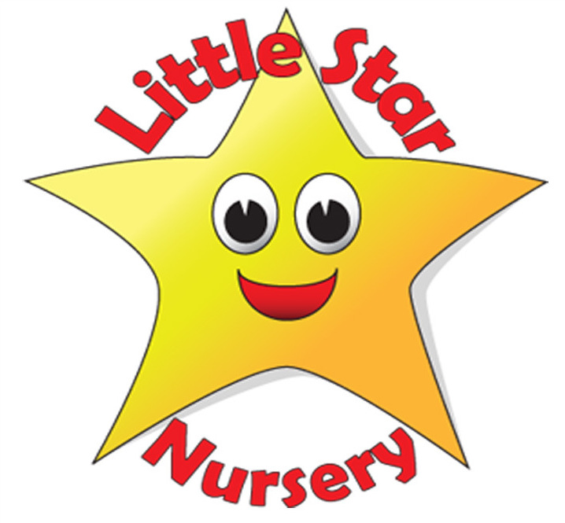
Little Star Nursery
Mission Statement
Reviewed and reissued: 2026 | Next review due: 2027
At Little Star Nursery, we ensure that ours is a place “where every child can shine”. We accept and embrace every form of individuality and strive to create a community where everyone is valued and accepted, and where everyone appreciates the needs of others, so that we can live in a mutually inclusive and accepting society across both our settings, in Farrington and Paulton. To achieve this goal, we promise to:

Our promises to children
- Provide a happy, safe, warm and stimulating environment for all children to play, learn and develop freely; where no child is bullied or suffers discrimination in any form from staff, students, volunteers, other parents or children.
- Meet the requirements of the Early Years Foundation Stage (EYFS) statutory framework, while offering a child-led curriculum rooted in the belief that children are capable, curious and creative learners.
- Focus on children's personal, social and emotional development in an age-appropriate way, ensuring children learn right from wrong and why we show certain behaviours towards others; to mix and share with all other children and value others' views; to know about similarities and differences between themselves and others; and to challenge negative attitudes and stereotypes.
- Actively embed strategies of emotion coaching, golden rules and conflict resolution to achieve the above goals (see Behaviour Policy).
- Always ensure that language is appropriate and not offensive or discriminatory, with consideration to tone of voice, pitch and levels of discussion.
- Help children to develop responsibility for themselves and their actions, and to become competent, confident, independent and co-operative individuals.
- Value and take each child's contributions seriously, listening to their voice and actively involving children in the planning of activities wherever possible.
- Encourage children to have a positive attitude and respect for both themselves and other people, and promote the fundamental British values of democracy, the rule of law, individual liberty, and mutual respect and tolerance of those with different faiths and beliefs.
- Recognise the intrinsic worth of each child and family, regardless of economic or social background or any protected characteristic under the Equality Act 2010.
- Offer inclusive services that are accessible to all children, including children with special educational needs and disabilities (SEND), making reasonable adjustments so that every child can take part fully (see SEND Policy and Equality and Equal Opportunities Policy).
- Regularly monitor the services we provide, and our equipment and resources, and invest in new materials as necessary to meet the needs and preferences of the children.
- Avoid any form of favouritism towards children in our care.
- Keep children safe and promote their welfare, including online. We will protect children in our care and be alert to any safeguarding and child protection issues in a child's life at home or elsewhere. We will take action to protect children from harm and will be alert to harmful behaviour by other adults in a child's life.

Our commitment to parents and carers
Little Star Nursery is committed to meeting the needs of parents and carers by:
- recognising and respecting families' beliefs, customs and traditions;
- promoting a positive relationship with parents and carers, and working in partnership with them to provide high-quality play, education and care for their children;
- listening and responding to their views and concerns with respect and understanding, and making it easy to raise a concern or complaint (see Complaints Policy);
- keeping them informed of our policies and procedures;
- sharing and discussing their child's achievements, experiences, progress and friendships, along with any difficulties that may arise;
- always maintaining appropriate professional boundaries towards families;
- being aware of the need for confidentiality within our professional practice, and handling personal information in line with data protection law and our Confidentiality and Data Protection Policy. Confidential information will not be disclosed unless required by law, or to protect the interests or welfare of the child;
- encouraging a two-way dialogue about their children's care, learning and development; and
- signposting any relevant outside agencies or support that may be of use and benefit to the family.

Our commitment to keeping children safe
Safeguarding children is everyone's responsibility. No single practitioner can have a full picture of a child's needs and circumstances, so everyone who comes into contact with children and families has a role to play in identifying concerns, sharing information and taking prompt action, in line with Working Together to Safeguard Children (2026).
Safeguarding a child's wellbeing is all of our responsibility, and we follow the detailed guidance in our Safeguarding and Child Protection Policy (2026).

